Project Contract

This is your project contract form. The deadline is **5/11/2021**. Remember to tick "Send me an email receipt of my responses" at the end of this page to receive a confirmation email. Please note that you need to forward the "confirmation email" to your supervisor in order to validate this submission.

1.Student Name: Vashishth Keshavji

2.P-number: P2425256

3.Programme: Software Engineering

4.Email address: P2425256@my365.dmu.ac.uk

5.Project Title: E-commerce Web system – Merchandise (Clothes, Shoes and accessories)

6.Project Proposer:

7.Supervisor: Areej Polina

8.Introduction (max. 100 words): E-commerce is the activity of buying and selling of products on online service. Ecommerce web system of merchandise allows user to easily buy clothes, shoes and accessories using Web interface or mobile application. This also allows to user to browse different products according to their preference. Allowing them to search and filter products by different type of categories. Users will have option to create an account for returned orders and simplified order tracking, review, and history. Users will have abilities to preview and modify the content of the order before placing order. Backend will allow to store Customer, staff, stock, and manufacturing data.

9.Project Background (max. 300 words): Everyone now days wants their day-to-day life easier, independent, and effortless. Everyone wants to stay up to date with latest trends and merchandise with minimal effort of going through hassle of buying products. Easily browse product by different type of categories such as by genders, fashion trends and type of clothing. Buying product through Ecommerce website makes user experience of buying product effortless. It eliminates going to shop, wating in queue for purchase. This project can be further develop with smart home assistance system. For example, home assistance like Alexa can be used to see order update, track process of shipment and could be used to get reminders of delivery. Alexa can be used for reding out new offers to the user on product if they are in wish list or in their basket.

10.Aims (max. 100 words): The aim of the project to develop a system which allow user to buy and sell product easier and effortless.

11.Objectives (max. 200 words):

Development of:

Front-End

* Homepage.
* Category pages.
* Product landing pages.
* Checkout page.
* About us.
* Search bar and search results page.
* Account registration and login forms.
* Email subscription form

Back-End

* Stock management
* Order processing
* Staff management
* Review management

12.Deliverables (max. 100 words):

- **Reports**: documentation

- Project contract, Ethical review, and Global checklist

- Deliverable 1

- Literature review

- Diagrams such as ERD, UML, UI Design

- Test design

- Deliverable 2 - Final report

* Project management – at least 10 meeting recorded.
* Test Results

- **Prototype**

- interface for functions such as add, filter, search and share

- interface for placing order

- sign up / login interface

- recommendation and notification components

- system manual/documentation

**- Viva and demonstration**

13.Resources and Constraints (max. 100 words):

Resource requirements:

* Hardware – laptop/desktop
* Software – visual studio/phpStrom, Atom (PHP/HTML/CSS/C# coding environment)
* Version control – OneDrive, GitHub
* Database – azure

14.Sources of Information (max. 100 words):

* php.net
* w3.org – for linked database
* existing systems
* Reading material
* Academic licences for online journals databases,
* Library books.

15. Risk Analysis (max. 100 words):

* database and server connection/failure problems
* loss of reports and codes – to avoid use multiple backups of file
* hard drive crashes – use of version control environment to avoid
* project management

16.Schedule of Activities (max. 300 words):



**Bold = Main Task**

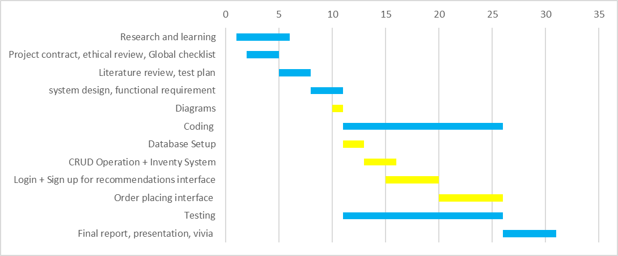

X = Duration in Weeks Y = Tasks Blue = Main Task Yellow = Sub task

17.Student Signature: Vashishth

18.Supervisor Signature:

19.Date: 04/11/2021